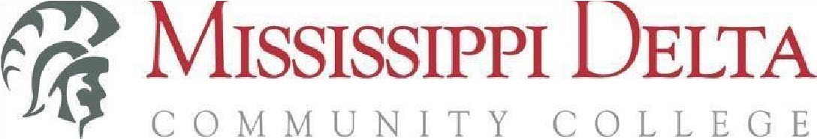

**NOTICE OF VACANCY**

**Assistant Football Coach (Part-time)**

**REPORTS TO:** Head Football Coach

**DESCRIPTION OF POSITION:** At Mississippi Delta Community College (MDCC) we value the ability to serve students from a broad range of socioeconomic backgrounds, genders, abilities, and orientations. We prioritize applicants who demonstrate they understand the benefits a diverse student population brings to a community college. The successful Assistant Football Coach will be an equity-minded individual committed to student success by collaborating with faculty, staff, administration, students and community partners who support the institution’s mission.

The Assistant Football Coach, under the direct supervision of the Head Football Coach, is responsible for assisting the Head Football Coach in the management and administration of the MDCC Football program and team. Areas of responsibility include but is not limited to academics, community involvement, on-field instruction, recruiting, and student athlete relations.

More specifically, the Assistant Football Coach is responsible for the following:

# DUTIES AND RESPONSIBILITIES

* Addressing academic concerns and ensuring student-athlete compliance with NJCAA rule
* Assisting with game-day strategy and substitutions
* Assisting with recruiting visits and camps.
* Assisting with strength and conditioning programs
* Breaking down game film to identify strengths and weaknesses of opponents
* Contacting high school coaches and players.
* Coordinating travel arrangements for games and recruiting trips
* Creating scouting reports for upcoming games
* Identifying potential student-athletes.
* Leading drills and individual position work during practice sessions.
* Maintaining player data and statistics
* Monitoring player progress and providing feedback
* Organizing practice schedules and equipment
* Working with specific player groups to improve skills and techniques.
* Perform other duties assigned by the Head Football Coach and/or Athletic Director.

# MANDATORY QUALIFICATIONS

* Bachelor’s degree from an accredited college or university.
* Some Collegiate Coaching experience.

# KNOWLEDGE AND SKILLS REQUIRED

* Demonstrated knowledge of MDCC rules and regulations governing recruitment.
* NJCAA and MACCC Eligibility and related functions are required.
* Demonstrate ability to maintain a high degree of confidentiality.
* Ability to effectively manage time and priorities.
* Ability to prioritize office workflow and make effective administrative decisions to increase efficiency, accuracy, and productivity.
* Demonstrated ability to tactfully and effectively communicate (written and verbal) with a variety of individuals.
* Strong critical thinking skills.
* Demonstrates organizational ability, and attention to detail and accuracy.
* Ability to work independently as well as in a team environment.
* Ability to work evenings or weekends as needed. Ability to work well in a fast-paced setting.
* Ability to work well under pressure.
* Excellent interpersonal skills.
* Knowledge of and skills in implementing various fundraising and recruiting strategies •
* Knowledge of and skills in using effective communication to attract the target audience
* Possess a creative and strategic mindset.
* Skilled in Microsoft Office including Word, Excel, Access, PowerPoint and Outlook
* Skills and abilities in organization, time management, and record keeping
* Ability to collaborate and communicate effectively with other professionals in a team setting.
* Ability to develop knowledge of, respect for, and skills to engage with those of other cultures or backgrounds.

# PHYSICAL DEMANDS

The physical demands described here are representative of those that must be met by an employee to successfully perform the essential functions of this job. Reasonable accommodations may be made to enable individuals with disabilities to perform the essential functions.

While performing the duties of this job, the employee is regularly required to use hand to finger, handle, or feel objects, tools, or controls; reach with hands and arms; and talk or hear. The employee frequently is required to sit, stand and walk. The employee is occasionally required to climb, balance, stoop, kneel, crouch, or crawl.

The employee must occasionally lift and/or move up to 25 pounds. Specific vision abilities required by this job include close vision. This position may require prolonged periods of viewing a computer screen. This position requires travel and may require working some evenings and weekends.

# WORK ENVIRONMENT

The work environment characteristics described here are representative of those an employee encounters while performing the essential functions of this job. Reasonable accommodations may be made to enable individuals with disabilities to perform the essential functions. The noise level in the work environment is usually moderate to loud.

**TERMS OF EMPLOYMENT**

This is a Part-time, 12-month, Exempt, Non-Teaching Professional (NP) position**.**

# SALARY

The salary will commensurate with education and experience.

**APPLICATION PROCEDURES**

Applicants should submit all of the following in order for their application to be considered for employment:

1. MDCC Employment Application **(online only)**
2. ***Unofficial*** College Transcript(s)
3. Current Resume
4. Authority to Release Information Form/ Consent Form

The MDCC Employment Application can be found on the MDCC Human Resources website, <https://msdelta.formstack.com/forms/applicationforemployment>

Official transcripts **are required upon hire** and may be sent directly from the university/college electronically to humanresources@msdelta.edu or via postal mail to:

Office of Human Resources - P. O. Box 668 - Moorhead, MS 38761

# DEADLINE

# Internal/External– February 20, 2025 at 5:00 p.m.